You are developing a system for a university to manage course registrations. Each course must have a unique code that serves as its identifier. The name of the course varies in length but can be descriptive, often including terms like "Introduction to" or "Advanced Concepts in." Each course is led by a single instructor, and their full name is recorded without exceeding a length of 100 characters. The system also tracks the number of credit hours assigned to the course, which must be a positive whole number. For scheduling purposes, the day and time when the course starts are logged, capturing both the date and the exact time of the first session. Lastly, a field tracks whether the course has reached its enrollment capacity, indicating either true or false based on its status.

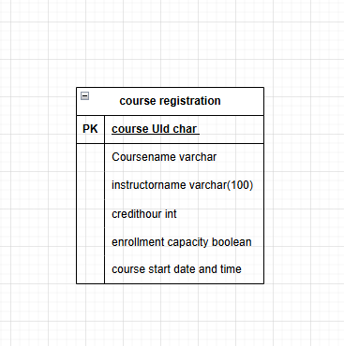Your task is to create a table for this course registration system by determining the correct data types based on the information provided.

You are tasked with building a system for a car rental service to manage its fleet. Each car in the system requires a unique identifier to differentiate it from others in the fleet. The make and model of the car are stored as text, with models typically including names like "Corolla" or "Civic." The year of manufacture for each car is recorded using a four-digit number. To track when a car was added to the fleet, the system stores the exact date of entry. Additionally, the rental service logs the car's daily rental price, which may have decimal points, such as 49.99. The system also needs to know the mileage on each car, which is a large number that increases over time. Finally, there is a field indicating if the car is currently available for rent, represented by a true or false value.

Your task is to design a table for the car rental system by identifying appropriate data types for each piece of information described.

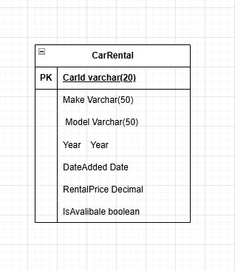

You are designing a database for an airline to manage passenger information on flights. The system stores a unique reference number for each passenger to ensure no two passengers have the same identifier. Passengers’ full names are recorded, which can vary in length but should not exceed a certain limit. The system tracks the passenger's seat number, which consists of a combination of letters and numbers, such as 12A or 23C. Additionally, the booking system needs to store the date of the passenger’s scheduled flight. To keep records of ticket pricing, the exact amount paid by each passenger is stored, which may include decimal values like 199.50. Each passenger's flight status is also maintained, indicating whether they have checked in or not, represented by either true or false. Lastly, the system logs the passenger's age as a whole number, ensuring it is greater than zero.

Your task is to create a table for this flight passenger management system by correctly identifying the data types for the information described.

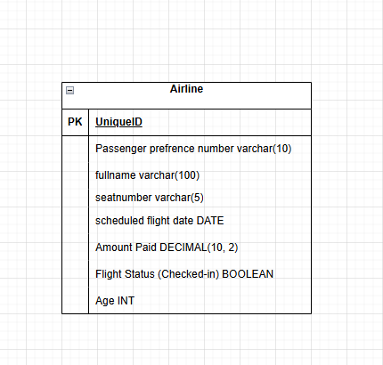

You are building a system for a fast-food delivery service to manage orders. Each order must have a unique identifier to track it across the system. The customer's full name is recorded, which can vary in length but should not exceed a reasonable limit. The system also stores the customer's delivery address, which includes multiple lines of text. For each order, the total amount paid is recorded, which may contain decimal values such as 15.99. The system tracks when the order was placed, storing both the date and exact time of the transaction. Additionally, a field stores the number of items in the order, which is always a positive whole number. Finally, the system needs to record whether the order has been delivered, with a simple true or false indicator.

Your task is to create a table for the fast-food delivery system by identifying appropriate data types for the information described.

